**3. Securely Storing Backups**

Google Drive account with my ICT Security Fundamentals Folder uploaded for safe off-site storage.

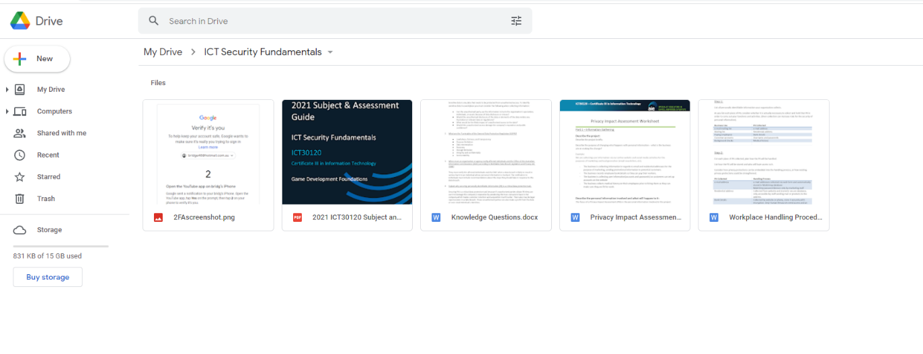

**4. Using Two-Factor Authentication**

Google requesting 2FA authentication from me to sign into my email/google account

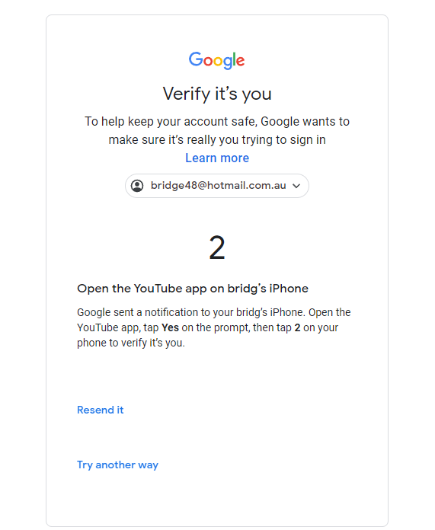

**5. Securely Storing Strong Passwords**

Using google password manager and generating a strong password to use(red circle).



